0Team Members: ____Shreeji Patel___ ________Richard Qing____ ________Credo Dotse____

Title Gem Grabs
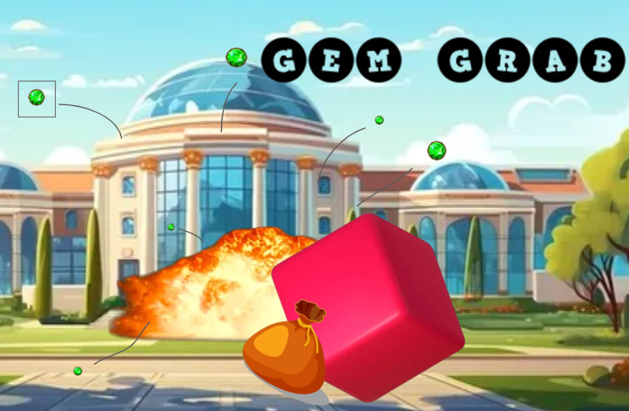
Tag line “Quick Reflexes, Big Rewards!”

Genre Puzzle/Maze and platformer

Target Everyone
.
Goal Collecting gems and dodging obstacles

Draft of Box Art

Plays like “The World's Hardest Game”________ _”Super Mario”__
Popular Game A Popular Game B or twist

Core Mechanics
- You control a square using the arrow keys and some special keys to use the power-ups and jumps
- You can also earn some skin in the game for your square.
- The goal: move from the green safe zone to another green safe zone.
- On the way you must grab a gem which allows you to unlock the next level of the game, kind of like a key to the door which you will need to access the final level of the game.
- In those levels you will have to pass through different traps like lasers spikes and many more just to grab the gem and get to the exit, and you can earn power-ups in the level or before it which can help you make it easier for you to pass through it.

Related Games (Optional, remove section if you don’t use it)
1. Title: The World's Hardest Game

Publisher or Developer: Stephen Critoph (also known as Snubby Land)

Genre/Platform: Maze, Puzzle

Year: 2008

Title: Super Mario

Publisher or Developer: Nintendo

Genre/Platform: Platform

Year: 1985

Game Project Summary
Supporting Screenshot / Drawings / Collage for Worlds / Levels / Characters / Game Items

Characters
The storyline follows Cubby, the main protagonist of the game. During the gameplay, he will be represented by a square, however during cutscenes and dialogues, he will have a design like that of a human. The main antagonists of the game are traps; such as beartraps, spikes, lasers, etc... That said, security guards will also be present. They take on a more active role, meaning that they will actively pursue Cubby, encouraging the player to not stay idle, and so improving the pacing of the game.

Setting
The game takes place inside a museum. To infiltrate into the museum, Cubby goes through its sewer system. Finding himself inside, Cubby explores many sections of the grand museum. We can design our levels to respect those sections.

Main game mechanics
Our game will follow a format comparable to Mario. The characters will operate in a 2-dimensional world, being able to move to the left, right and up (maybe even a crouch option). Their spawn rates and lethality are increased further up the levels. A simple health system will also be present. Power ups act as boosts that will help the player pass through the levels, and they can randomly appear in some levels. The main game mode will be the campaign mode. It’s going to have something resemblant to a linear layout. The secondary game mode will only be added if we have enough time to do so: the endless mode. It will just be Cubby trying to survive as long as possible without being caught.

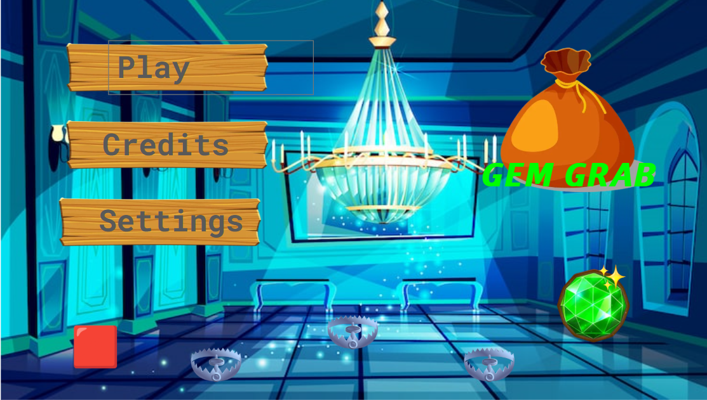
Supporting Screenshot / Drawings / Collage for Worlds / Levels / Characters / Game Items

